The Big Mac index
July 2016

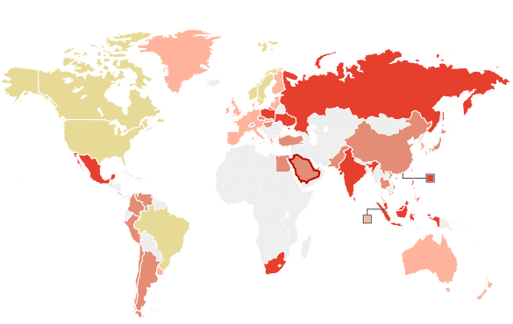

Undervalued by: |  | Overvalued by
- >50% |  | - 10-50%
- 25-50% | –/+ 10% | - 50-100%
- 10-25% |  | - >100%

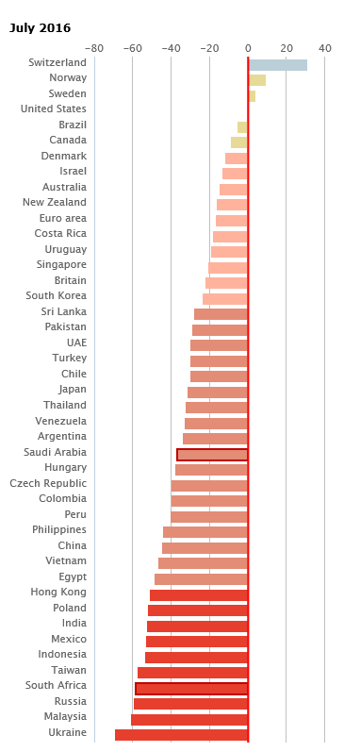

http://www.economist.com/content/big-mac-index

